
Guidelines
JOURNAL OF ECONOMIC SCIENCE

Journal of Economic Science is an international, peer-reviewed journal published by Indian Economists' Association Trust (IEAT).
The Journal has a website https://ieatrust.in/ which provides full postal and email addresses of Chief Editor and Editors, and these addresses are verifiable official addresses. Following criteria of UGC are mentioned in this guideline:
1. The website https://ieatrust.in/ provides complete instructions to author/reviewers
2. The Journal has a well-defined peer-review and publication policy
3. The journal has a well-defined Ethics policy
4. The Journal has a declared frequency of publication each year
5. The Journal is published regularly and in time following its declared frequency
6. The Journal is indexed in a given database in Google scholar and others
7. Journal levis no submission charges
8. The Journal is regularly published twice a year on six monthly basis.

Objectives
The journal is dedicated to encourage scholarly exchange among teachers, researchers, academicians, and policy makers. The journal is published bi-annually in print version. It is a freely accessible journal. Visit https://ieatrust.in/ for access. The Journal is published twice a year on six monthly basis – January-June, July-December. It is indexed in Google Scholar and efforts are on for abstracting/ indexing in many others. There is no submission fee.

Scope of the Journal
The scope of the journal includes all field of social sciences such as economics, sociology and social anthropology, political science and public administration, international studies, social geography and demography, commerce and management, social and allied psychology, education, law and human rights, environmental studies, energy, gender studies, national security and strategic studies. The journal provides open access to its content through website on the

principle that makes research freely available to the public domain and offer greater global exchange of knowledge.

Paper submission, Selection and Publishing Process
- Submission Acknowledgement
The journal accepts articles published by e-mail only. The soft copy of the paper may be submitted to nmpverma@gmail.com. When a manuscript is submitted through e-mail, a submission acknowledgement letter would be sent automatically by online system. The editorial assistant also sends an e-mail confirmation to the author/s within one to three working days. In case, the confirmation is not received, the author may check bulk e-mail box or contact the editorial assistants.
- Basic Review
The editor determines whether the manuscript fits the journal’s focus and scope. Next a check for the similarity rate is done. Any manuscripts out of the journal’s scope or containing plagiarism, including self-plagiarism, will be rejected. It is also cross checked by editors.
- Peer Review
The submitted manuscript will be reviewed by subject expert. The review process may take one to two months. The decision to accept or reject an article is based on the suggestions of reviewers. If differences of opinion occur between reviewers, the editor-in-chief will weigh all comments and arrive at a balanced decision based on all comments, or a second round of peer review may be initiated. The result of review will be sent to the corresponding author and forwarded to other authors.
- Journals Are Mailed
After publication, soft copies of the paper will be mailed to the corresponding author. The authors are requested to visit our website www. bbau.ac.in for the publication updates and other necessary information or enquire from editor`s office.
Copyright Policy
Copyrights for articles are retained by the authors, with first publication rights granted to the journal. Authors have rights to reuse, republish, archive, and distribute their own articles after publication. The journal/publisher is not responsible for subsequent uses of the work. The author/s will be asked to fill up the copy right form while submitting the papers (Please see Annexure 1 for copy right form).

Policy on Ethics & Standards
JES is a peer-reviewed journal. Its publication adds to network of knowledge. The journal is published with the collective efforts of publishers, editors, authors, and reviewers. All persons need to maintain highest level of professional ethics and standards.
Responsibilities of Publishers:

The publisher is dedicated to supporting the vast efforts of the editors comprising editor-in-chief, managing editor and associate editor, the academic contributions of authors, and the respected volunteer work undertaken by reviewers. The publisher may ensure that the publications works are done smoothly. The ethical guidelines are applied to assist the editors, authors, and reviewers in performing their duties.
Responsibilities of Editors:
The editor should acknowledge receipt of submitted manuscripts within five working days of receipt and ensure an efficient, fair, and timely review process.
The editors should process submitted manuscripts in a confidential manner. The manuscripts will not be disclosed other than the corresponding author, reviewers, and the publisher
The editors should withdraw himself / herself from processing manuscripts if he / she has any conflict of interest with any of the authors.
The editors may disclose the names and other details of the reviewers to a third party with the assent of the reviewers.
The editors have the right to make the final decision on whether to accept or reject a manuscript from publication viewpoint.
The editors should not insist the authors to cite his or her journal either as an implied or explicit condition of accepting their manuscripts for publication.
The editors should decline to use his / her own research any part of any data or work reported in submitted and as yet unpublished.
The editors should react sharply and take reasonable measures when an ethical complaint occurs concerning a submitted manuscript or a published paper. The editor should consult with the author for formal retraction or correction.

Responsibilities of Authors:
The author should not submit concurrent manuscripts to multiple journals. An author also should not submit any paper previously published anywhere to the journals for consideration. The author should present a precise abstract of his or her research containing an impartial aim, methodology, and findings its significance.
The author should honestly collect and interpret his or her research data. Publishers, editors, reviewers, and readers are entitled to request the author to provide the raw data for his or her research for convenience of editorial review and readers` access.
The author should guarantee that the works he or she has submitted are original. If the author has used work and/or words by others, appropriate citations are required. Plagiarism in all its forms constitutes unethical publishing behavior and is unacceptable.

The author should indicate sources that have supported the research and also declare any conflict(s) of interest.
The author should acknowledge to those who have made contributions to the research. Those who have contributed significantly to the research should be listed as coauthors. The author should ensure that all coauthors have consented for the final version of the paper and have agreed on its final publication.
The author should promptly intimate the editor regarding any obvious error(s) in his or her published paper and cooperate with the editor in correction of the paper. If the editor is notified by any party other than the author that the published paper contains an obvious error, the author should write a retraction or make the correction.
Responsibilities of Reviewers:
The reviewer who feels unqualified to review the assigned manuscript or feels that he or she cannot meet the deadline for completion of the review should promptly notify the editor and excuse himself or herself from the process of reviewing this manuscript.
The reviewer should inform the editor and abstain himself or herself from reviewing the manuscript if there is a conflict of interest. Specifically, the reviewer should abstain himself or herself from reviewing authored or coauthored by a known/related person with whom the reviewer has an obvious personal or academic relationship, if the relationship could introduce bias.
The reviewer should treat the manuscript in a confidential manner. The manuscript should not be disclosed to or discussed with authors/others except as authorized by the editor.
The reviewer should do the peer-review job objectively.
The reviewer should abstain for his or her own research any part of any data or work reported in submitted and as yet unpublished articles.
The reviewer should immediately notify the editor of any similarities/plagiarism between the manuscript under review and another paper either published or under consideration by another journal. The reviewer should immediately call to the editor‟s attention a manuscript containing plagiarized material or falsified data.
IEAT
Indian Economists' Association Trust (IEAT) is a registered academic society. It aims at promoting teaching and research in development studies and allied areas. The objective is sought to be achieved by organizing seminar and conferences, research courses, publishing books/journal and research papers reports. The authors are encouraged and expected to join as Life Member/Donor member of the Association. For form and formalities contact IEAT office bearers/members or visit https://ieatrust.in/.

General Guidelines for Paper Submission
Authors may submit full, original and unpublished paper that are not under review in any other journal. All submission should be in English. Manuscripts within 3000 to 5000 words in length are preferred. An abstract of about 100 words with three to five key words should also be submitted along with the paper. All manuscripts should be mailed in MS Word format. The manuscript should be accompanied by author/s declaration stating that the paper is his/her original work and has not been sent for consideration for publications in any other journals or edited book or elsewhere. The authors are encouraged to join as life member of the association. Following guidelines should be followed while submitting the paper.
General Guidelines: Referencing Style: APA 6, All Headings: Times News Roman, Bold and Font Size 12, Paper Margins Normal (2.54 cm, top & bottom and 3.17 cm, left & right), Font Size and Type: 12-pt. Times New Roman, Line Spacing: 1 line spacing throughout the paper, abstract, body of the document, references, appendices, footnotes, tables, and figures, Alignment Justified, Orientation Potrait, Page Size A4.
Guidelines for Abstract Submission: Title: Times News Roman, Font Size 12, Study Title: Times New Roman, Font size 12, Capitalize each word, Author 1 Last Name, First Name, Middle Name. Affiliation. Email, Author 2 Last Name, First Name, Middle Name. Affiliation. Email, Author X Last Name, First Name, Middle Name. Affiliation. Email, Presenter Author Name, Correspondence Author Name, Abstract Body: Times News Roman, Font size 12, Justify margins, Line, Spacing 1, Maximum 300 words, Keywords: Three to Five keywords, Referencing Style: APA 6.
Guidelines for Full paper Submission: Abstract: Follow the Guidelines as aforesaid, Main Heading: Times New Roman, Bold, Font size 12 and Upper Case, Second Heading Indented
1.27cm left, Times New Roman, Bold, Font size 12 and Capitalize Each Word, Third Heading: Indented 2.54cm left. Times New Roman, Bold, Font size 12 and Capitalize Each Word.
Table: in the Center of the Page, Table Layout: Auto Fit Window, Table Caption: Above the Figure, Figure: in the Center of Page, Above and Below the Inserted Figure and Table, One Line Free Space, Figure Caption: Above the Figure.

The Journal

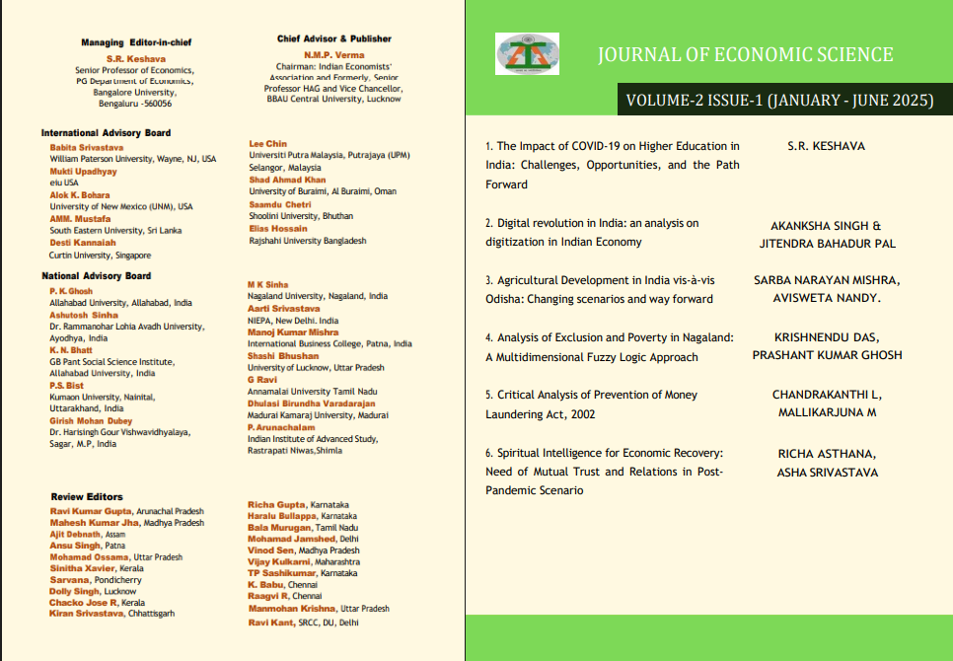

Chief Advisor & Publisher
N.M.P. Verma Chairman: Indian Economists’ Association and Formerly, Senior Professor HAG and Vice Chancellor, BBAU Central University, Lucknow

Editor-In-Chief
S.R. Keshava, Senior Professor of Economics, Post-Graduate Department of Economics, Bangalore University, Bengaluru - 560056 & Managing Editor and Secretary of IEAT

Announcements

1. | Call for Papers:
 | The journal calls for original and unpublished paper all the year round. Complete manuscript strictly following the guidelines may be submitted to nmpverma@gmail.com.
2. | Peer Reviewers
JES welcomes academicians, professors and researchers to participate as honorary peer reviewers after joining as IEAT life/donor member.
Eligibility Criteria:

Post-Doctoral research experience/ Publications Senior academic job at a university or organization Fluency in English (academic and professional) Strong interest and expertise in scholarly publications Speed and accuracy

Interested Candidate is requested to mail one page CV to the editor-in–chief at nmpverma@gmail.com.

Annexure 1

Copyright Form
Editor-in-Chief
Journal of Economic Science
Indian Economists' Association Trust
Lucknow-226025
Email: sr_keshava@yahoo.com

The copyright to this article is transferred to the above journal being jointly published by Indian Economists' Association Trust. The author(s) declare(s) that his/her contribution is original, not copied from other sources, and not submitted elsewhere for publication. It has undergone plagiarism test. All the references have been cited correctly. Guidelines for paper submission have been strictly adhered to. The author signs for and accepts responsibility for releasing this material on behalf of any and all coauthors. The copyright transfer covers the exclusive right to reproduce and distribute the article, including reprints (offline, online) or any other reproductions of similar nature.

Title of Paper

Author(s): Name and Signature

Corresponding Author’s Name and Signature:

Date:
Place:

JES PAPER REVIEW FORM

Paper Title:
Reviewer’s Name:
(The reviewers' identities may remain anonymous to author/s)
( ) Excellent, accept the submission (E)

( ) Good, accept the submission with minor revisions required (G) ( ) Acceptable, revisions required (A)
( ) Decline the submission (P)
Recommendation to Editor (Please mark “Y” for appropriate option)
❖
The editor-in-chief will forward the section below to author/s

- Evaluation (Please evaluate the manuscript by grade ( E, G , A, P ) as given
below
E=Excellent G=Good A=Average P=Poor
Items | Grade
Contribution to existing knowledge
Organization and readability
Soundness of methodology
Evidence supports conclusion
Adequacy of literature review
- Strengths
- Weaknesses
- Instructions to Author/s

JOURNAL OF ECONOMIC SCIENCE
Indian Economists' Association Trust, Lucknow

Invoice
Invoice No.: _______________

Date: _____________________

Name of Subscriber: - ________________________________________________________________________

Address: ___________________________________________________________________________________

District: _____________________ State: ____________________ Pin code: ______________________

Contact No._________________________________

Quantity | Name of Journal | Price | Total
1. | Indian Economists' Association Trust  Vol. Issue Year | Rs.1000  per issue + Postage charges extra
Total

Payment can be made by Demand Draft/Cheque, NEFT/RTGS/UPI, or e-transfer, in favour of Indian Economists Association Trust, payable at Lucknow, India. For online payment:
A/c No. 110030081143,
Bank: Canara Bank, BBA University, Lucknow-226025, India
IFSC Code: CNRB0002900
SWIFT Code: CNRBINBBKFD

